GGP-ICET - SG trend team 8/20/2013 09:20:00 PM
The following tasks should be investigated and realized by the GGP trend team.

Determination of SG calibration factors
The SG calibration (or scale) factor can only be obtained by comparison with a known signal. This signal can be the natural temporal gravity variation (mainly the solid Earth's tides) or well known artificial accelerations. The calibration factor should be determined with an accuracy better than 0.1%, which cannot be achieved by regular AG observations over a period of 24 hours.
VP: I can’t agree that the accuracy of 0.1% can’t be achieved using regular observations with duration of 24 hours. In the graph and table below you can se calibrations of the OSG-050 with short (<2 days) and long (2-5 days) AG observations. The scale is same and in both cases accuracies below 0.05% were reached. The calibrations with longer duration may look as more efficient (less drops and higher accuracy) but this fact is caused mainly by related higher tidal variations. From my point of view, if the claimed accuracy of 0.1% should be reached, we need roughly 10-20 days of simultaneous measurements and it is no problem when we will use 10-20, 1-day measurements. Moreover, I’m quite sure that the scale itself will be more robust for five 2-day campaigns instead of two 5-day campaigns. I guess, that this is caused especially by the fact that SG calibration need a concentrate AG operator with perfect alignment of the meter, which can’t be ensured for too long measurements. Of course from practical point of view, when AG is not regularly in the observatory, it is necessary to use several days AG observations. I guess that three 4-5 days measurements with tidal variations >200 μGal are able to reach accuracy of 0.1%.
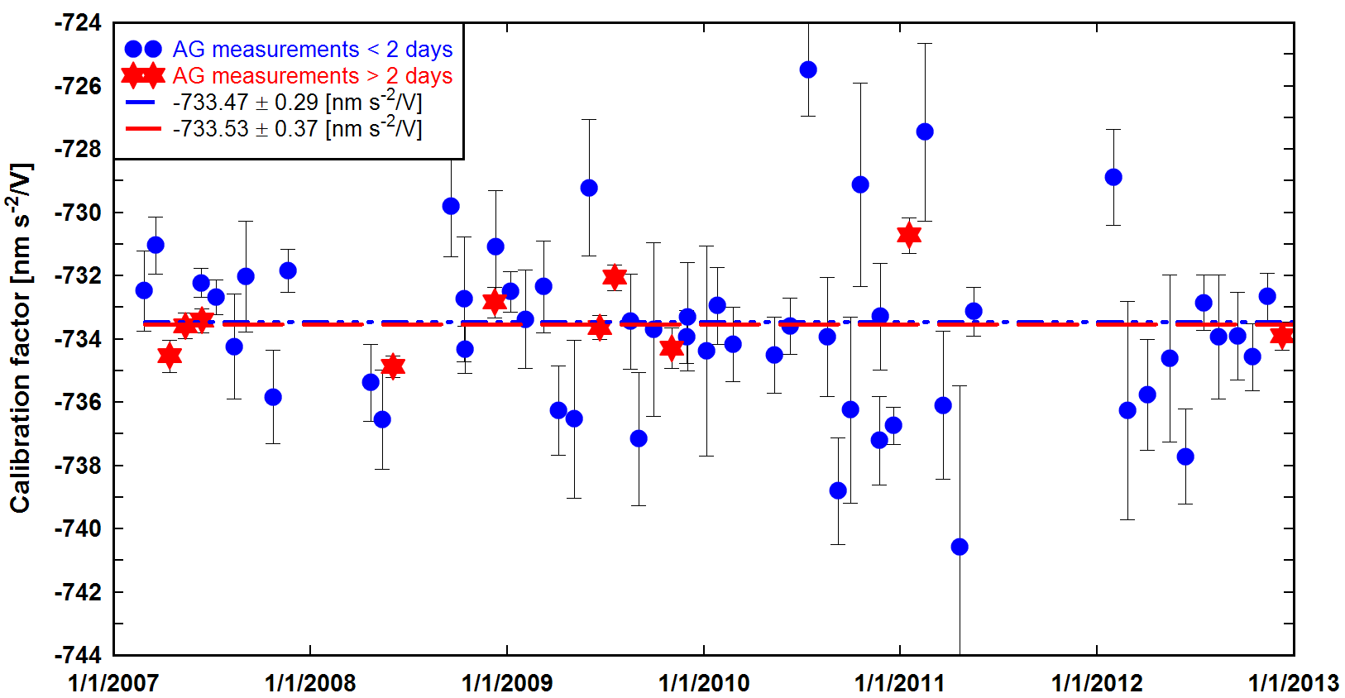

 | Number of campaigns | Duration in total [days] | Average daily tidal variation [μGal] | Drops in total | Calibration factor
AG < 2 days | 53 | 54 | 170 | 148445 | -733.47 ± 0.29
AG > 2 days | 10 | 24 | 240 | 81412 | -733.53 ± 0.37

Options:
- Parallel recordings of SG and AG
  - Data to be used:
    - Individual AG drop results and filtered SG data. Unfiltered SG data (1s) should be avoided because of the considerable amount of microseismic background noise. It should be discussed whether interpolated SG data of lower sample rate (e.g. 10s) are suitable. VP: Personally, I’m using 1-min data interpolated to the given second of a particular drop. I can imagine that the best would be to use 1-sec data after low pass filtering with cut off period of few minutes (depending on the parasitic mode), but I have no special investigation on this issue. I would suggest adding that the SG instrumental time lag has to be taken into account when SG data are related to AG data.
    - AG set mean values and corresponding SG mean values
  - Accuracy estimates based on the precision of individual SG/AG comparisons are often too optimistic. Repeated comparisons do not only demonstrate repeatability but provide more robust error estimates. Should there be a recommendation about the number of SG/AG comparisons? This would contribute to consistent results.
  - The minimum length of AG observation period (Meurers 2012)/Wziontek et.al. (2012):
period | accuracy
24 h^{*)} | not better than 0.15%
1.5 to 2 days | about 0.1%.
~3 days | less than 0.1%
~5-7 days | less than 0.02%
*) regular AG measurement
AG setup periods over several days might need re-alignment of the instrument to avoid systematic effects. It should be discussed, if a long AG observation should be split into several parts, e.g. setups over 3 days. The AG should not be re-aligned during the comparison period. Systematic effects can be reduced by removing a linear drift model over the comparison period. It should be investigated if the number of drops during long AG observations can be reduced to avoid excessive wear of the AG.
VP: I tried to compute my results with and without including linear drift to AG data. I’m happy that I did not find any difference (-733.50 ± 0.21 vs. -733.42 ± 0.20) and the AG drift term was statistically insignificant. If linear drift is included to AG data it shows that something is WRONG with AG measurements. I know the paper of Bruno and also Imanishi’s paper, where clear AG drifts were detected. So, this is really strange and should be explained somehow: 1) problem of operators, 2) problem of gravimeter. It might be connected with the task of re-alignment of the meter. I know that some operators even didn’t touch the verticality or fringes during the calibration campaign. However, this is a completely WRONG procedure and may directly cause artificial signals as drifting of AG results. Other situation may happen during AG measurements as interferometer re-alignment or set-up change. The corresponding errors are higher than the repeatability of the meter. Therefore, in such a cases, it is much better to split the calibration into several parts.

- Parallel recordings with a well calibrated, transportable SG (e.g. iGrav): Scale factors can be transferred better than 0.02% with comparison periods > 10 days
- Parallel recordings with well calibrated relative (spring) gravimeters, allows a similar accuracy as approach a) (Meurers (2012), Wziontek et.al. (2012))
- Calibration by artificial accelerations with a calibration platform allows higher accuracy (better than 0.05 %), but presumes modeling of the transfer function and is still under development.
Experiments 1.a) and 1.c) should be scheduled for a period of large tidal variation.

Storage and availability of SG calibration factors
Calibration results should be stored independently from GGP-files in a database to offer best available and most recent values and to document changes or improvements. Further, the period must be defined for which a specific calibration factor is valid (exchange of electronics/filters). It should be tested, if the GGP file header could be automatically updated when requested for download.

Separating SG drift from geophysical trends
Using repeated AG observations, the SG drift can be separated from a trend in gravity. Here, small deviations (‘offsets’) between AG should be considered although AG deviations and SG drift are highly correlated. Ideally, the AG deviations would be consistently determined at different SG stations, reducing the correlation. A link to the AGrav database could support this. Two cases should be distinguished:
- Mean values of an AG observation are compared to the corresponding mean value of the residual SG record for the same period. Identical corrections for time-dependent gravity effects are essential, e.g. for LP-tides, atmospheric correction, polar motion (applied or not applied). Preferably, the corrections applied to the SG time series should be adopted from the AG processing, since reprocessing of AG observations using other models can only be done in cooperation with the responsible AG group.
- Using individual AG drops: Here, the preprocessed, but uncorrected data from AG and SG can be used. However, a considerable numerical effort is the consequence.
The AGrav database could be used as AG data source since several GGP stations are already present. Currently, only mean values for AG measurement epochs are routinely stored, but the database is capable of storing both, AG set- and drop-results, but this needs involvement of the database administrator. Without storage of AG drop-results, automatic drift determination is only possible if consistent corrections were applied to SG and AG time series. Such corrections must be agreed on and followed by both data providers, AG and SG teams. Special care is needed with respect to LP-Tides and atmospheric corrections (air pressure admittance / alternatives, e.g. Atmacs).
VP: I suppose that for AG offset issue and consequently for SG drift determination, the comparisons of AGs should serve as a reference. Combination of 1) results at AG comparisons, 2) AG measurements at SG stations, 3) SG data with unknown drift parameters should provide information concerning variability of AG offset (or its reproducibility) and SG drift.

Managing SG steps
The simultaneous determination of SG drift and AG offsets needs a careful preprocessing, especially for SG steps. However, in special (and rare) cases, SG steps can only be determined by AG observations. SG steps are recursive and therefore an independent storage from the GGP files is proposed. These steps should be applied by the user before analyzing the SG data. A simple table with time, perturbation length and step size could serve for this purpose. The step sizes should be expressed in units of measurement (Volts) to allow calibration factor changes, but should be defined in the (tide free) residuals only. Primarily, SG steps should be provided by the SG operator. However, the step amount could be checked with an algorithm, fitting simple functions (linear, quadratic, eventually splines) at both sides of the step to the residual time series. In special cases, the determination could be included in the drift determination by AG observations. Automatic detection of steps should be avoided.

Discussion
- What recommendations for SG calibration by AGs should be given (minimum observations time, linear trend fit, alternatives)? Should AG drop data be available from AGrav?
- Does any analysis exist, which compares the impact of the tidal variation on the quality of the scale factor? Low tidal variation results obviously in a larger scatter of the calibration factors (Fig. 1).
- How could a proper SG drift determination be ensured by using AG mean values e.g. from AGrav database (standards for LP-Tides, Polar motion correction applied etc.).
- Is there a strong evidence for a non-linear long term drift of the SGs besides the analysis of Van Camp and Francis for C-021 in Membach, which would suggest a general recommendation?
VP:The graph below show a slight change of the SG drift at Pecny. However, this very small variation might be also caused by variation of AG offset, even it was not detected at any comparison.
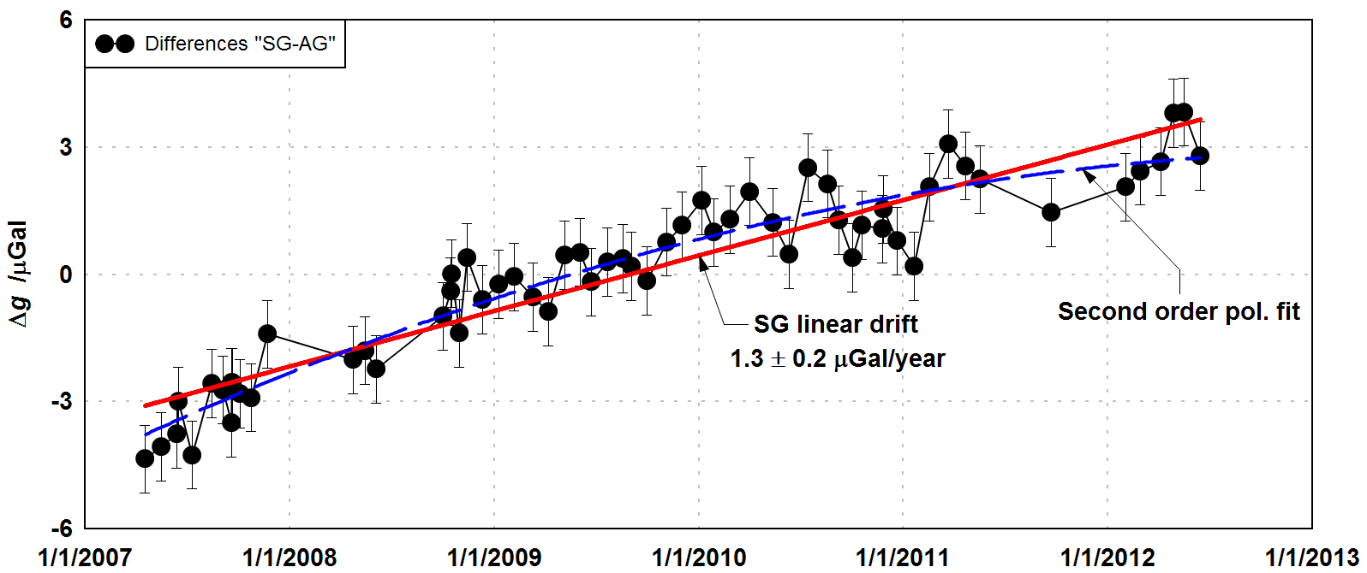
References:
Meurers, B. (2012): Superconducting Gravimeter Calibration by Colocated Gravity Observations: Results from GWR C025 International Journal of Geophysics, 954271, doi:10.1155/2012/954271
Van Camp, M, Francis, O. (2007): Is the instrumental drift of superconducting gravimeters a linear
or exponential function of time? Journal of Geodynamics 81:337–344, doi: 10.1007/s00190-006-0110-4
H. Wziontek, B. Cordoba, D. Crossley, H. Wilmes, P. Wolf, J.M. Serna and R. Warburton (2012): Stability and accuracy of relative scale factor estimates for Superconducting Gravimeters, Geophysical Research Abstracts, Vol. 14, EGU2012-12642-1, EGU General Assembly 2012

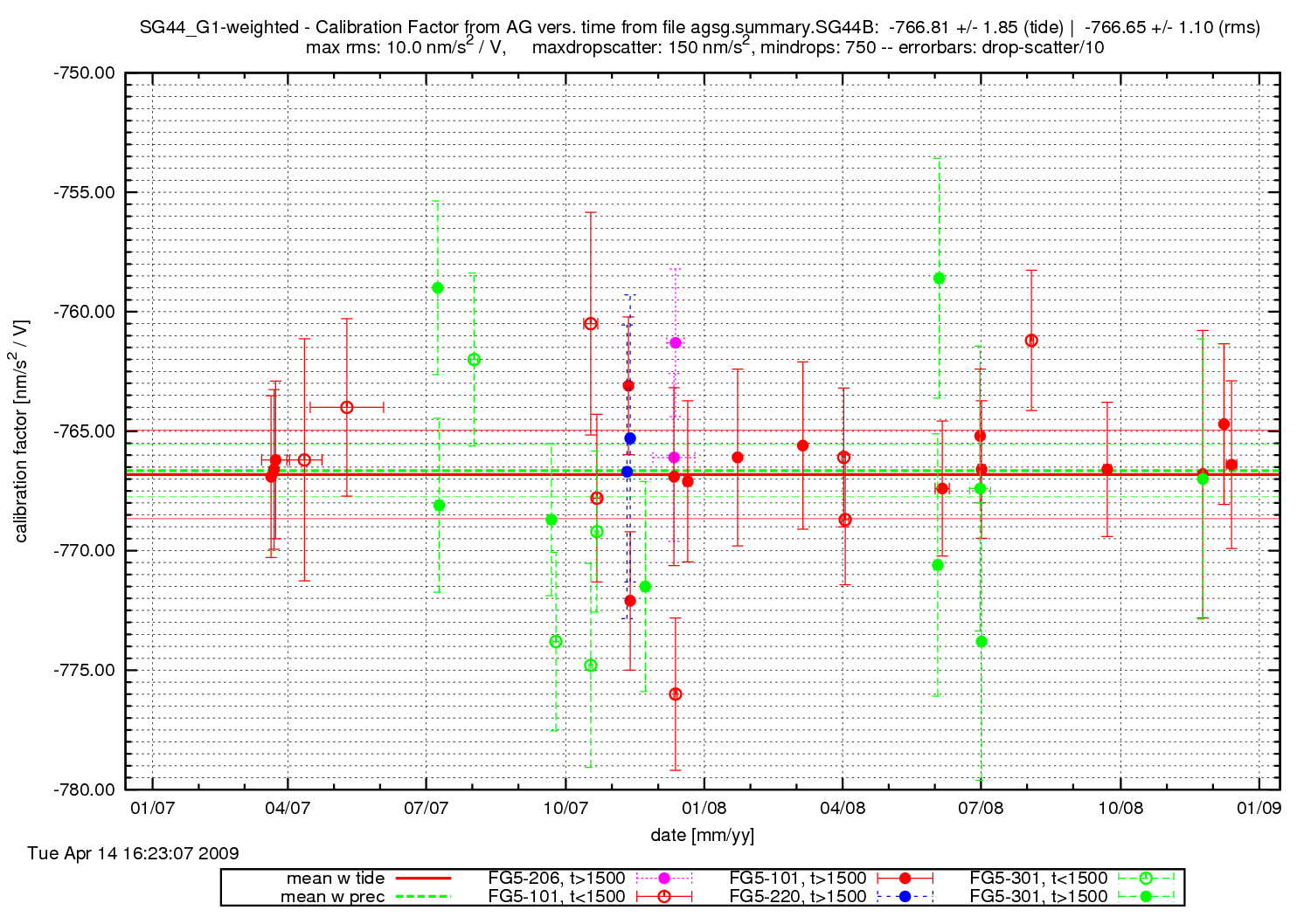
Fig. 1: Scale factors obtained from FG5-observations at station Bad Homburg. Most of these are regular observations over 24 hours. Filled circles indicate tidal variation > 150 µGal.
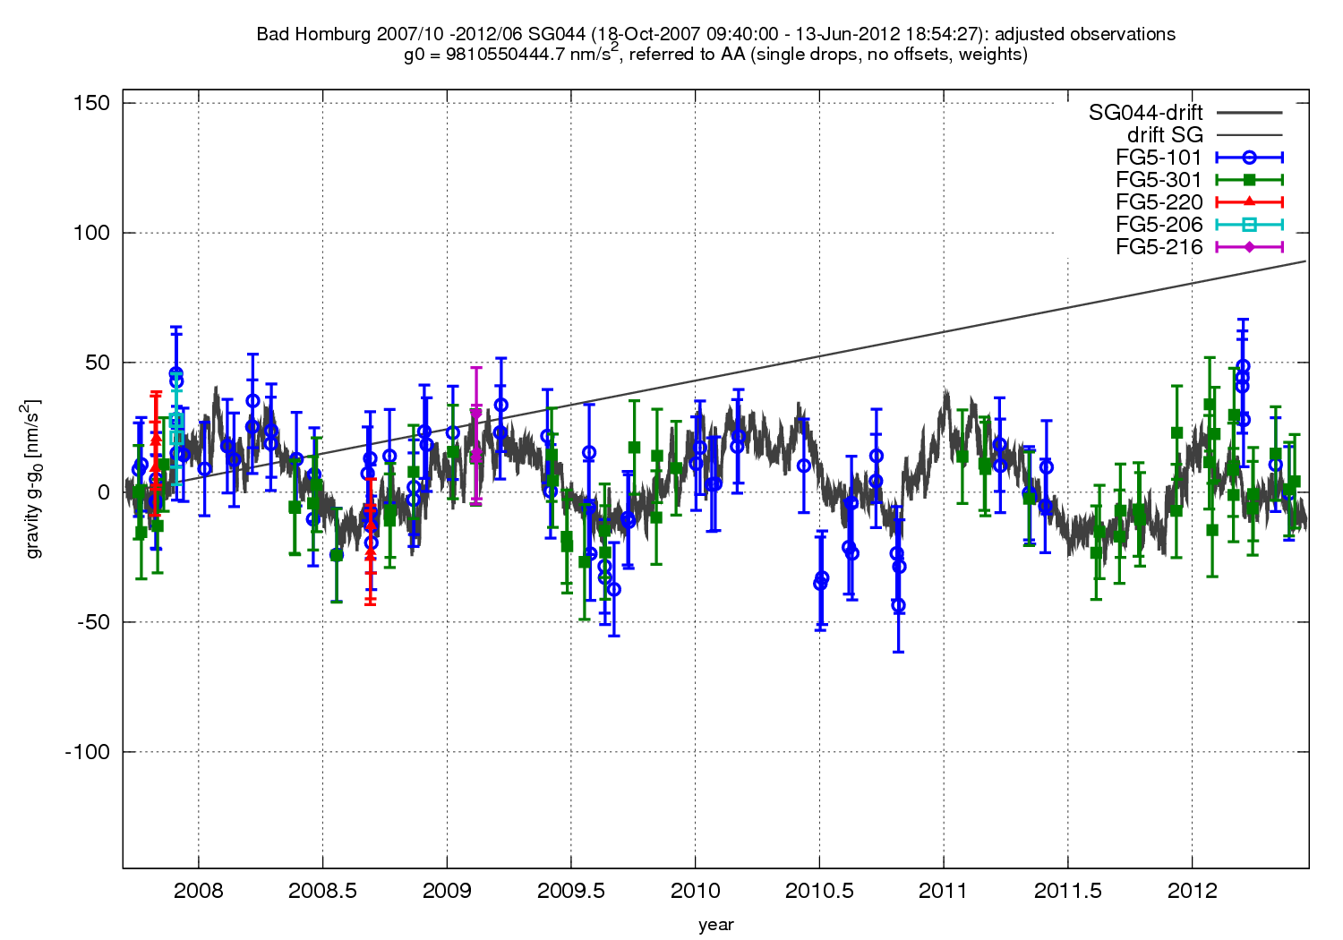
Fig. 2: Example for a combination of AG observations with SG residual time series for Station Bad Homburg, Germany. A linear instrumental drift for the SG as well as AG deviations (one for each AG) are removed.

