Improving GGP data base content

To prepare the tasks of the future ICET-GGP Service it is important to try to optimise the GGP data flow.
Different data sampling rates are coexisting:
- 1s or 10s original data sampling kept by the data owner and sent to IRIS
- 1min decimated data uploaded on the GGP data base under raw or corrected form.
- 1h decimated data provided as a secondary GGP product
Original data sampling is used for applications in seismology (free oscillations) or local short term perturbations e.g. pressure effects.
1min data are used as a standard for preprocessing. However the decimation filters are spreading the perturbations especially the spikes and it should be recommended to correct the original data before decimation to one minute.
1h data are used as a standard for tidal analysis. Given the structure of the tidal spectrum higher sampling rates, e.g. minute, are not bringing additional information. However with the increased data storing and computing power there are no more economic reasons to avoid direct analysis of one minute sampled data, as tidal analysis methods are able to deal with higher sampling rates. It should be noted that filters for 1min sampled data are not available for ANALYZE .
Studies of long period phenomena, e.g. polar motion, are generally using hourly samples. However daily values could be sufficient for very long-term phenomena.
Let us examine the different constrains linked with the different decimation and processing steps.

- Keeping track of the corrections

Corrections are applied on the raw minute data to suppress spikes, major earthquakes and jumps. These corrections are necessary to improve the signal to noise ratio for tidal analysis. However jumps corrections can change the long term behaviour of the data and only instrumental steps, e.g. following helium refill, should be removed when the study of long period phenomena is considered.
We propose to add an additional channel in the corrected minute data to keep track of these corrections (Table 1, Figure 1). If we define the corrections as
Corrections = Raw - Corrected
The raw data can always be recovered by the formula
Raw = Corrected + Corrections.

- Changes of calibrations

Calibration changes of previously uploaded minute data can only be taken into account by uploading again the corrected minute data multiplied by the scale factor SF, with
SF = new calibration/old calibration.
As a matter of fact this updating procedure is seldom performed at the minute data level as the tidal analysis programs ETERNA or VAV allow to introduce the scale factor SF in the header of each data block. However, up to now, this correction is only applied on the hourly data (*h2.ggp) which are usually used for tidal analysis.
A simple solution consists in uploading corrected minute data in Volts and not in nm/s². The calibration being then entered as a scale factor in the ETERNA format (Table 2).
These minute gravity data expressed in Volts can be decimated to one hour and used directly for tidal analysis by ETERNA or VAV as the scale factor will be used again as calibration.
- Time lag

In the tidal analysis the time lag is only used to shift the astronomical tide. As a result the residues directly computed by the ETERNA program are the same if the analysis is performed with or without the time lag correction. These residues correspond thus to the original data without time lag.
For tidal gravity predictions it is necessary to use the tidal analysis results including the time lag correction. However the subtraction of this tidal prediction from the original data will leave abnormally high tidal residues in the tidal band.
The only way to correct the data from the time lag is to shift the sampled data by the corresponding number of seconds. TSOFT provides this possibility (Table 3). The drawback of this solution is indeed that the procedure should be reiterated if the time lag value is modified later on. Moreover, as the largest time lags reach only 30 s, the effect is already negligible for long period tides (less than 0.01° for Mf) on one side and as modern SG instrumentation is equipped with low filtering devices with time lags of a few seconds only on the other, the time lag correction is only important for tidal analysis studies which does not require time shift of the data.
___________________________________________________________________________
Table 3 : application of the Tsoft “shift sample frame” option to correct a 30s time lag

Initial data

00h19m 00h20m 00h21m
1206.36 1214.18 1222.87

shift sample frame with options +30s, reinterpolate data points YES

00h19m30s 00h20m30s
  - 1218.25

shift sample frame with options -30s, reinterpolate data points NO

00h19m 00h20m 00h21m
1210.20 1218.25 1227.57

NET RESULT : advance of 30s of the observed data equivalent to a time lagcorrection of 30s
___________________________________________________________________________

- Computation of residues

As explained above the lowest tidal residues will be obtained by subtracting the tidal model derived from analysis without time lag correction. Only higher frequency tides i.e. D, SD, TD,.. will be available as the tidal analysis is not providing reliable results for LP tides.
There is another approach to eliminate the diurnal (D) and higher frequency (SD, TD,..) tides, keeping the low frequency signal including the LP tides: low pass filtering of the data. It has the advantage to be independent of any tidal model. The filters built by the Tsoft program are very efficient to eliminate the higher frequencies tides (D, SD, TD,…) with half filter length of 2 days (2880minutes, Figure 2) without attenuation of the LP tides. Local pressure data should be filtered in a similar way for later use. Subtraction of theoretical tidal signal with observed tidal parameters for higher frequency tides provides equivalent results (Figure 3).
The local pressure correction should not be applied at that level to allow improved corrections later on.
The direct subtraction of an observed tidal model is not expanding the existing gaps in the data. The model is easily recovered as data – residues.

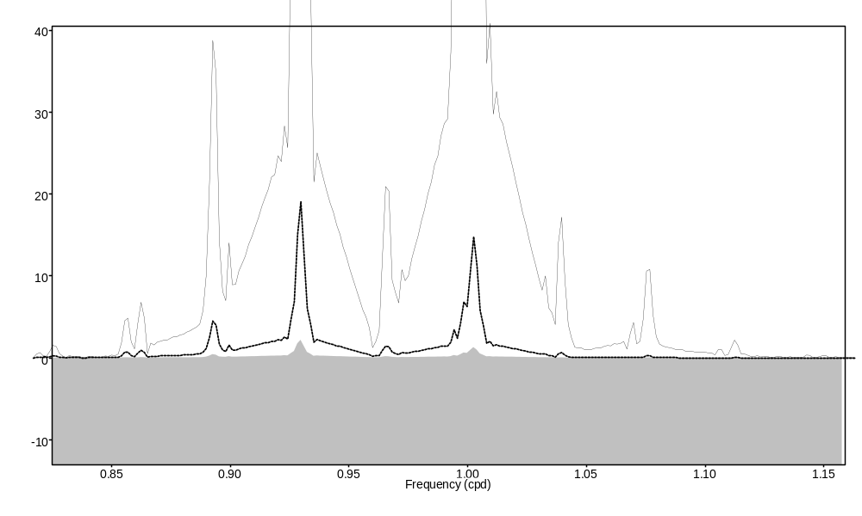
Figure 2: spectrum in diurnal band after least squares filtering of corrected minute data with a 0.5 cpd cutoff frequency
Full line : original signal
Dotted line: filtered with half length 1440 minutes
Grey: filtered with half length 2880 minutes

- Decimation from minutes to hours

Care has to be taken to avoid attenuation of the higher frequency tides. For Tsoft users there is a minimum least-squares filter length. The half filter length 480 suggested in the Tsoft manual is too short. A half filter length of 1440 minutes (1 day) is suitable to reduce M2 attenuation below the 10⁻⁴ level (Table 4). By comparison the ETERNA filter g1m1h.nlf has an half length of 2152 minutes.

Table 4: attenuation of M2 as a function of half filter length (Apache point, 2010/03-2011/05)
Half filter length |  | δ_{M2} | attenuation
minutes | hours | Associated Error ±.00006
400 | 8 | 1.16175 | 0.99950
600 | 10 | 1.16204 | 0.99975
1200 | 20 | 1.16228 | 0.99995
1440 | 24 | 1.16232 | 0.99998
2160 | 36 | 1.16232 | 0.99998
4320 | 72 | 1.16233 | 1.00000

The drawback of long filters is an increase of data loss on each side of an even short interruption. However for studies of phenomena with periodicities larger than one day shorter decimation filters coupled with the elimination of higher frequency tides is still possible.

- Proposals for an improved GGP data handling

Let us consider first the core of the data base as it is existing now.
For the corrected minute data we suggest:
  - introducing the applied corrections as a third channel;
  - introducing a fourth channel with residues eliminating higher frequency tides i.e. D, SD, TD… bands and keeping all the longer period signals. These residues will be preferably computed by subtracting a tidal model computed without time lag correction. Local pressure correction should not be applied to allow global ones;
  - storing the corrected gravity data, corrections and residues in Volt and pressure in hPa to avoid reiterated uploading if calibrations are changed.
For the tidal analysis we suggest:
  - using directly one minute sampled data to avoid any decimation problem
  - designing a new ETERNA filter for 1min sampled data
  - using an half filter length of one day (1140 minutes) minimum when hourly data are computed
The proposed four channel structure (corrected gravity data pressure, corrections and residues) will be easily integrated in a larger data base including additional channels e.g. global pressure or sea level corrections. In that case it will be better to decimate the four channels from minutes to hours.
Table 1: monthly ETERNA file expressed in nm/s² with corrections. Note the unit value for the scale factor (in bold) as the data are expressed in physical units.

DATA CORRECTED AT ICET (bf.ducarme@gmail.com)
Filename : AP100422.ggp
Station : Apache Point, New Mexico, USA
Instrument : GWR OSG 046
Time Delay (sec) : 1.5400 0.0100 nominal
N Latitude (deg) : 32.78036 0.0010 measured
E Longitude (deg) : -105.82042 0.0010 measured
Elevation MSL (m) : 2788.0000 5.0000 measured
Gravity Cal (uGal/V) : -79.3300 0.1000 tides
Pressure Cal (hPa/V) : 1.0000 0.0001 nominal
Author : Tom Murphy (tmurphy@physics.ucsd.edu)
yyyymmdd hhmmss grav(nm/s**2) press(hPa) corr(nm/s**2)
C******************************************************
INSTR 1.0000 1.0000 1.540 0
77777777 0.0 0.0 0.0
20100401 000000 1054.021 723.608 1.516
.
.
.
20100404 223000 153.804 726.201 1.517
20100404 223100 152.993 726.180 1.517
20100404 223200 152.125 726.197 1.515
20100404 223300 151.183 726.214 1.517
20100404 223400 150.299 726.200 1.510
20100404 223500 149.493 726.176 1.664
20100404 223600 148.630 726.180 1.860
20100404 223700 147.750 726.200 0.710
20100404 223800 146.941 726.207 0.873
20100404 223900 146.152 726.217 13.823
20100404 224000 145.370 726.235 8.691
20100404 224100 144.678 726.233 -58.371
20100404 224200 144.071 726.213 -23.644
20100404 224300 143.484 726.197 330.993
20100404 224400 142.910 726.186 854.433
20100404 224500 142.362 726.177 1181.025
20100404 224600 141.793 726.185 1136.671
20100404 224700 141.184 726.216 986.404
20100404 224800 140.611 726.245 748.850
20100404 224900 140.136 726.252 342.159
20100404 225000 139.733 726.245 54.640
.
.
.
20100404 233900 155.274 726.315 4.013
20100404 234000 156.303 726.320 3.933
Table 2: monthly ETERNA file expressed in V with corrections. Note that the scale factor (in bold) corresponds to the calibration factor as the data are expressed in Volt.

DATA CORRECTED AT ICET (bf.ducarme@gmail.com)
Filename : AP100422.ggp
Station : Apache Point, New Mexico, USA
Instrument : GWR OSG 046
Time Delay (sec) : 1.5400 0.0100 nominal
N Latitude (deg) : 32.78036 0.0010 measured
E Longitude (deg) : -105.82042 0.0010 measured
Elevation MSL (m) : 2788.0000 5.0000 measured
Gravity Cal (uGal/V) : -79.3300 0.1000 tides
Pressure Cal (hPa/V) : 1.0000 0.0001 nominal
Author : Tom Murphy (tmurphy@physics.ucsd.edu)
yyyymmdd hhmmss gravity(V) pressure(hPa) corrections(V)
C******************************************************
INSTR -793.3300 1.0000 1.540 0
77777777 0.0 0.0 0.0
20100401 0 -1.328654 723.608 -0.001912
.
.
.
20100404 223000 -0.193879 726.201 -0.001913
20100404 223100 -0.192856 726.180 -0.001912
20100404 223200 -0.191762 726.196 -0.001910
20100404 223300 -0.190575 726.214 -0.001913
20100404 223400 -0.189461 726.200 -0.001904
20100404 223500 -0.188444 726.176 -0.002097
20100404 223600 -0.187357 726.180 -0.002345
20100404 223700 -0.186248 726.200 -0.000896
20100404 223800 -0.185228 726.207 -0.001101
20100404 223900 -0.184233 726.217 -0.017425
20100404 224000 -0.183247 726.235 -0.010954
20100404 224100 -0.182375 726.233 0.073581
20100404 224200 -0.181610 726.213 0.029805
20100404 224300 -0.180870 726.197 -0.417236
20100404 224400 -0.180147 726.186 -1.077062
20100404 224500 -0.179456 726.177 -1.488750
20100404 224600 -0.178738 726.185 -1.432839
20100404 224700 -0.177970 726.216 -1.243418
20100404 224800 -0.177249 726.245 -0.943969
20100404 224900 -0.176649 726.252 -0.431311
20100404 225000 -0.176142 726.245 -0.068877
.
.
.
20100404 233900 -0.195731 726.315 -0.005058
20100404 234000 -0.197029 726.320 -0.004957

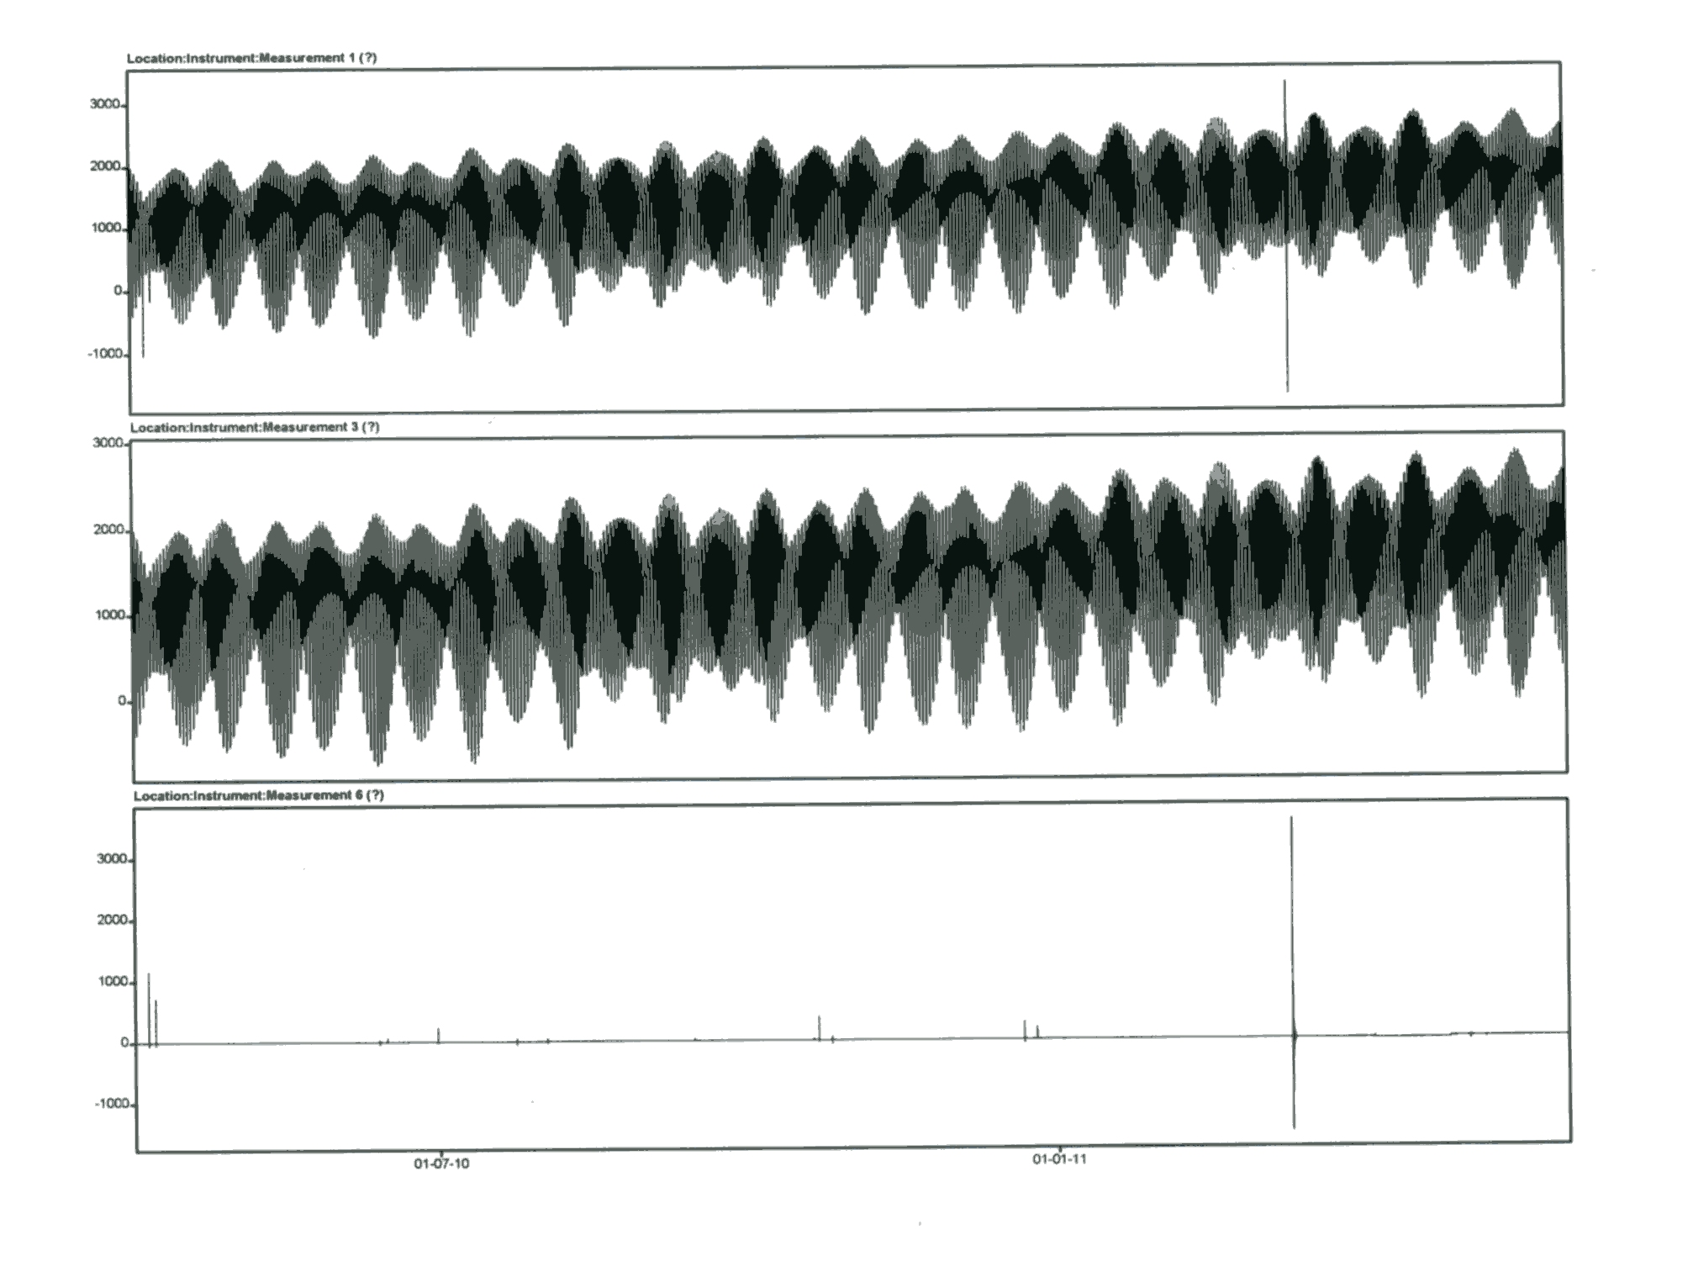
Figure 1: corrected data (middle) = raw data (up) + corrections (bottom)

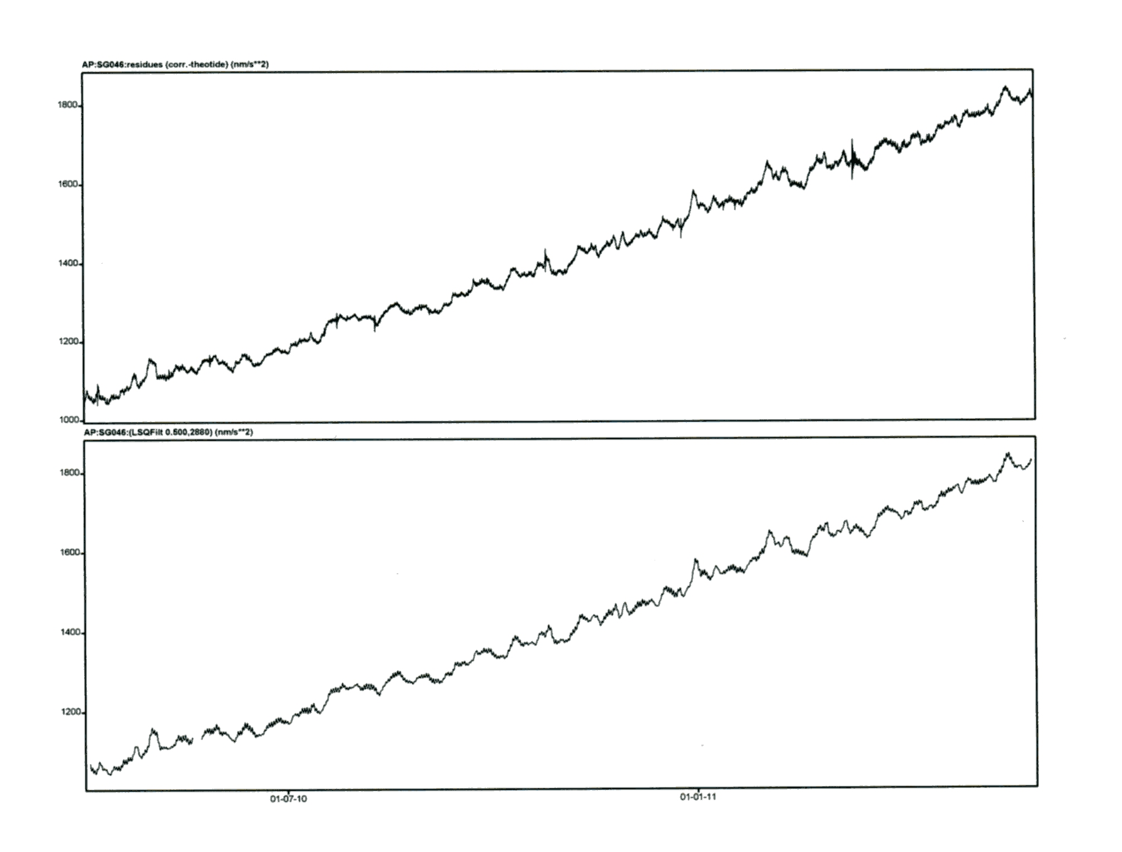

Figure 3: computation of residues (minute sampling)
Upper: observed gravity minus theoretical model deduced from observations;
Lower: least squares filtered data with cutoff 0.5 cycle/day and half filter 2880 min.
A small gap is expanded due to the large filter length.

